**Student Questions**

Learn about the internals of a standard PC case by examining physical samples and selecting and labeling images found on-line. Gain deeper knowledge by researching and reporting on specific components.

PC Tower Case

1. Find one (or more) images that clearly show the internals of a PC Tower Case.   
   (i.e. Google images using keywords “PC Case Internals”)  
   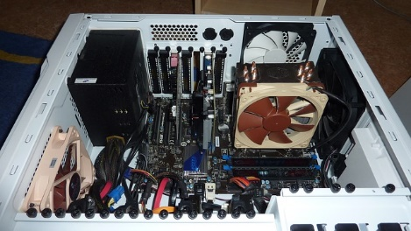
2. Clearly label the following components (using arrows) on your image of the PC case internals:
   1. Motherboard

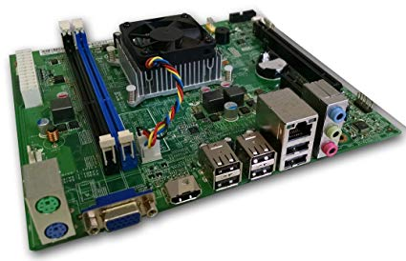

* 1. Power Supply

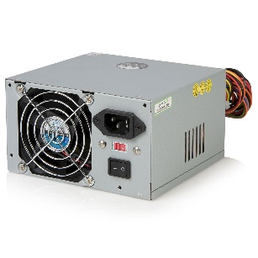

* 1. Hard Disk Drive

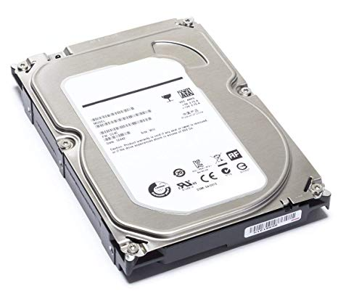

* 1. Optical Disk Drive (e.g.DVD)

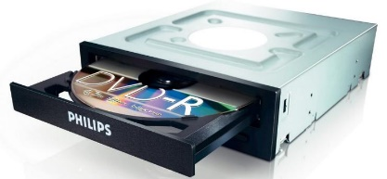

* 1. USB Expansion Ports

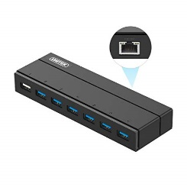

* 1. Monitor Port

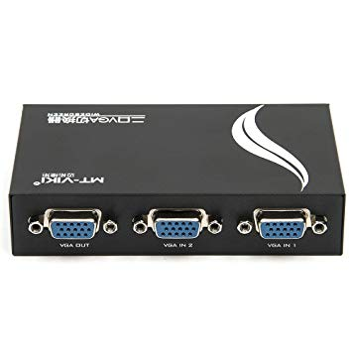

* 1. Audio Ports

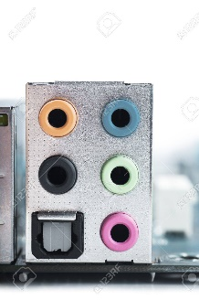

* 1. Ethernet Port

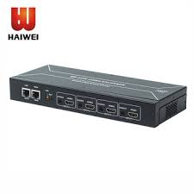

* 1. Cooling Fan

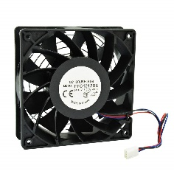

1. Research more in-depth about “Hard Disk Drives”. Make notes on the following:
   1. What different versions are currently available (speed and capacity)

-Parallel Advanced Technology Attachment (PATA)

-Serial ATA (SATA)

-Small Computer System Interface (SCSI)

-Solid State **Drives** (SSD)

* 1. How the capacity of the component has changed since the 1980’s  
     The first hard disk drive (RAMAC 305 produced by IBM) back in 1956 could store 5MB of data, which was a huge amount at the time. This is coincidentally also the size of the first “small” 5.25-inch hard disk drive that arrived in 1980.

PC Motherboard

1. Find one (or more) images that clearly show the layout of a PC Motherboard.   
   (i.e. Google images using keywords “PC Motherboard”)  
   
2. Clearly label the following components (using arrows) on your image of the PC motherboard:
   1. CPU (and fan)

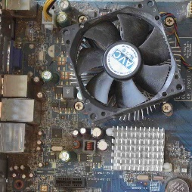

* 1. RAM Memory

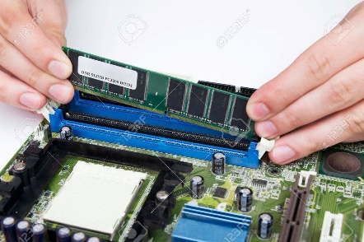

* 1. Disk Drive Interface (IDE or SATA)

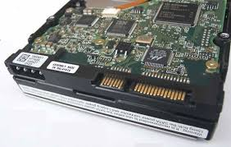

* 1. GPU Graphics Processor (either on-board or Graphics Card)

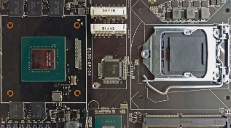

* 1. Sound Processor (either on-board or Sound Card)

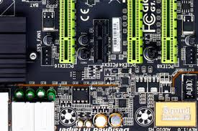

* 1. Wi-Fi / Ethernet Network Interface (either on-board or Graphics Card)

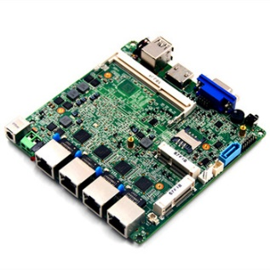

1. Research more in-depth about “CPU Processor Chip”. Make notes on the following:
2. What different versions are currently available (speed and capacity)

In the CPU, there are two primary components. ALU (arithmetic logic unit) - performs mathematical, logical, and decision operations. CU (control unit) - directs all the processors operations.

1. How the speed of the component has changed since the 1980’s  
   The chip was built in 350 nm, carried 5.5 million transistors and initially ran at clock speeds of 150 and 200 MHz. Just about a year later, Intel introduced the Pentium MMX, the first chip to receive significant components from Intel's development team in Haifa, Israel

Peripheral Devices

1. Find one (or more) images that clearly show the layout of the back of a typical PC tower case.   
   (i.e. Google images using keywords “Back Of PC Tower”)
2. Clearly label the following components (using arrows) on your image of the back of a typical PC tower case:
   1. Power cord and power switch

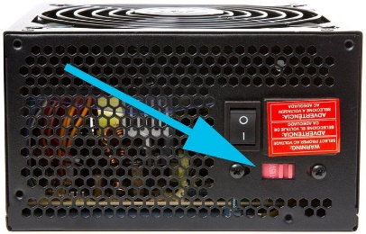

* 1. Monitor Interface (VGA or DVI or HDMI)

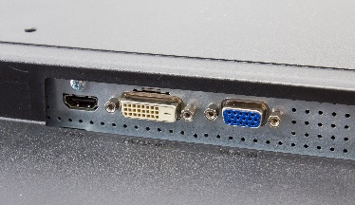

* 1. Mouse Interface (USB or PS/2)

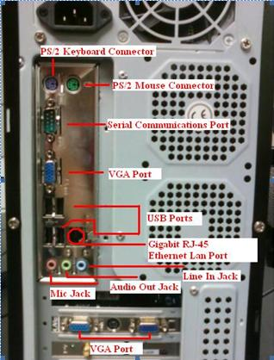

* 1. Keyboard Interface (USB or PS/2)



* 1. USB Ports



* 1. Audio Inputs / Outputs



* 1. Ethernet Interface



1. Research more in-depth about “External Portable Storage”. Make notes on the following:
2. Floppy Disks

A floppy disk drive (FDD), or floppy drive, is a hardware device that reads data storage information. It was invented in 1967 by a team at IBM and was one of the first types of hardware storage that could read/write a portable device. FDDs are used for reading and writing on removable floppy discs.

1. CD-ROM / DVD / Recordable CD/DVD

Short for Compact Disc Read-Only Memory, a CD-ROM is an optical disc that contains audio or software data whose memory is read-only. ... A CD-ROM drive cannot read a DVD, including movie DVDs and data DVDs. The format of a DVD is different than a CD, and a CD-ROM drive is not designed to read the format of a DVD.

1. USB Memory Drives

A flash drive is a small, removable hard drive that plugs into a USB port on your computer. ... Flash drives are a convenient way to bring your files with you and open them on a different computer.

1. Compact Flash Memory

A Compact Flash card (CF card) is a memory card format developed by SanDisk in 1994 that uses flash memory technology to store data on a very small portable device. ... CF cards today are primarily used as removable memory for higher-end digital photo and video cameras.

1. Cloud Based Storage

Cloud storage is a cloud computing model in which data is stored on remote servers accessed from the internet, or "cloud." It is maintained, operated and managed by a cloud storage service provider on a storage servers that are built on virtualization techniques.